NAME : Shri Harshini Devi . A
REG.NO : 192524104
Dept. Name : B.Tech -AIDS
Course Code/Course Name: DSA06 /Data Handling and Visualization
Date: 22/07/2026

LIST OF EXPERIMENTS

13. Dataset: Geographic Data

1. Create a map chart to visualize the distribution of cities on a geographic map. Label the map elements.

# Install packages (run once)
install.packages("leaflet")

# Load library
library(leaflet)

# Create dataset
city <- c("City A", "City B", "City C")
population <- c(500000, 700000, 600000)
temperature <- c(75, 68, 80)
elevation <- c(1000, 800, 1200)

# Sample latitude and longitude
lat <- c(13.0827, 12.9716, 11.0168)
lon <- c(80.2707, 77.5946, 76.9558)

data <- data.frame(city, population, temperature, elevation, lat, lon)

# Create map
leaflet(data) %>%
addTiles() %>%
addCircleMarkers(
lng = ~lon,
lat = ~lat,
radius = ~population / 100000,
color = "blue",
fillOpacity = 0.7,
popup = ~paste(
"<b>", city, "</b><br>",
"Population:", population, "<br>",
"Avg. Temperature:", temperature, "°F<br>",
"Elevation:", elevation, " m"
)
) %>%
addLegend(
position = "bottomright",
colors = "blue",
labels = "City Locations",
title = "Cities"
)

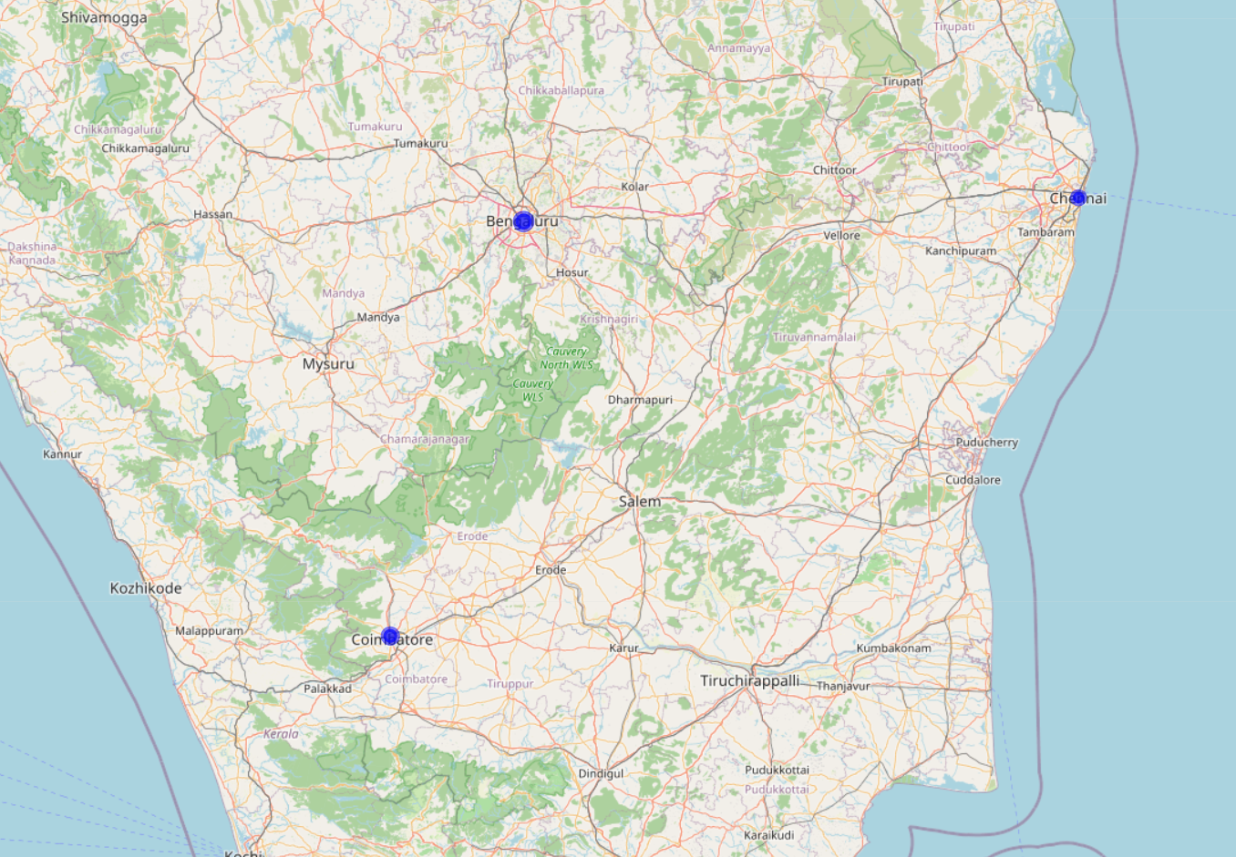

2. Generate a scatter plot to explore the relationship between average temperature and population size. Explain any insights.

# Create dataset
city <- c("City A", "City B", "City C")
population <- c(500000, 700000, 600000)
temperature <- c(75, 68, 80)
elevation <- c(1000, 800, 1200)

data <- data.frame(city, population, temperature, elevation)

# Scatter Plot
plot(
data$temperature,
data$population,
main = "Average Temperature vs Population",
xlab = "Average Temperature (°F)",
ylab = "Population",
pch = 19,
col = "blue",
cex = 1.5
)

# Add city labels
text(
data$temperature,
data$population,
labels = data$city,
pos = 4,
cex = 0.8
)

Insights
- 📍 City B has the highest population (700,000) but the lowest average temperature (68°F).
- 📍 City C has the highest average temperature (80°F) with a moderate population (600,000).
- 📍 City A falls between the other two in both temperature and population.
- 📍 With only three data points, there is no clear positive or negative relationship between average temperature and population. A larger dataset would be needed to identify any meaningful trend.
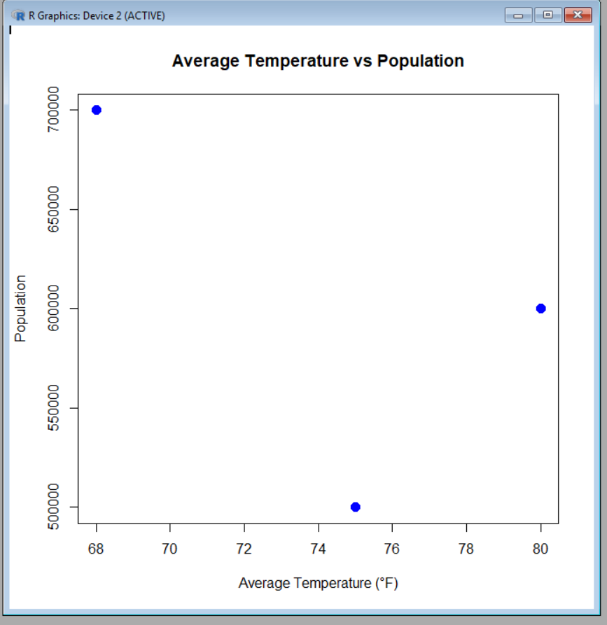

3. Build a table to display the geographic data for each city. Label the table elements.

# Create dataset
city <- c("City A", "City B", "City C")
population <- c(500000, 700000, 600000)
temperature <- c(75, 68, 80)
elevation <- c(1000, 800, 1200)

# Create data frame
geographic_data <- data.frame(
City = city,
Population = population,
Avg_Temperature = temperature,
Elevation = elevation
)

# Display table
print("Geographic Data Table")
print(geographic_data)

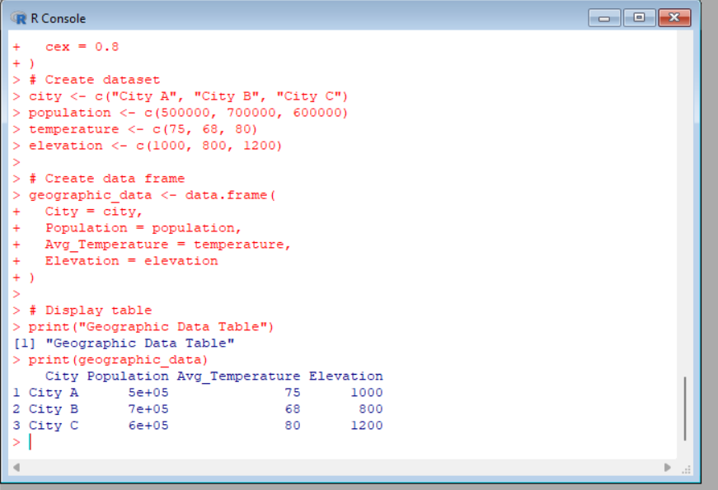

4.Develop a Tableau dashboard combining the map chart, scatter plot, and the table for interactive
exploration of geographic data.

Tableau Dashboard: Geographic Data
Dashboard Title: Geographic Data Analysis Dashboard
Steps to Create the Dashboard
- Import the Dataset
  - Open Tableau.
  - Connect to the Geographic Data dataset (Excel/CSV).
- Create Sheet 1 – Map Chart
  - Drag City to the canvas.
  - Assign the Geographic Role (or use Latitude and Longitude if available).
  - Drag Population to Size.
  - Drag Avg. Temperature and Elevation to Tooltip.
  - Rename the sheet Map Chart.
- Create Sheet 2 – Scatter Plot
  - Drag Avg. Temperature to Columns.
  - Drag Population to Rows.
  - Drag City to Label.
  - Choose Circle as the Marks type.
  - Rename the sheet Scatter Plot.
- Create Sheet 3 – Table
  - Drag City, Population, Avg. Temperature, and Elevation to the Text shelf.
  - Rename the sheet Geographic Data Table.
- Create Dashboard
  - Click New Dashboard.
  - Set the dashboard size to Automatic.
  - Drag the three sheets onto the dashboard:
    - 🗺️ Map Chart (Top Left)
    - 📈 Scatter Plot (Top Right)
    - 📋 Geographic Data Table (Bottom)
- Add Interactivity
  - Go to Dashboard → Actions → Add Action → Filter.
  - Source Sheets: Map Chart and Scatter Plot.
  - Target Sheets: Scatter Plot and Geographic Data Table.
  - Run Action: Select.
- Format Dashboard
  - Add the title "Geographic Data Analysis Dashboard".
  - Show legends for Population.
  - Display tooltips with:
    - City
    - Population
    - Average Temperature
    - Elevation
Final Dashboard Layout
----------------------------------------------------------
Geographic Data Analysis Dashboard
----------------------------------------------------------
| Map Chart | Scatter Plot |
| | |
----------------------------------------------------------
| Geographic Data Table |
----------------------------------------------------------
Dashboard Features
- 🗺️ Interactive Map Chart displaying city locations.
- 📈 Scatter Plot showing the relationship between Average Temperature and Population.
- 📋 Data Table listing all city information.
- 🔍 Selecting a city in the map or scatter plot filters and highlights the corresponding record in the table for interactive exploration.
14. Dataset: Survey Results

- Create a stacked bar chart to display the distribution of answers for Question 1. Label the chart elements.

# Create dataset
respondent <- c(1, 2, 3)
Q1 <- c("A", "B", "C")
Q2 <- c("B", "A", "A")
Q3 <- c("C", "D", "B")

survey <- data.frame(respondent, Q1, Q2, Q3)

# Count responses for Question 1
q1_count <- table(survey$Q1)

# Create stacked bar chart
barplot(
rbind(q1_count),
main = "Distribution of Responses for Question 1",
xlab = "Question 1",
ylab = "Number of Respondents",
col = c("red", "green", "blue"),
legend.text = names(q1_count)
)
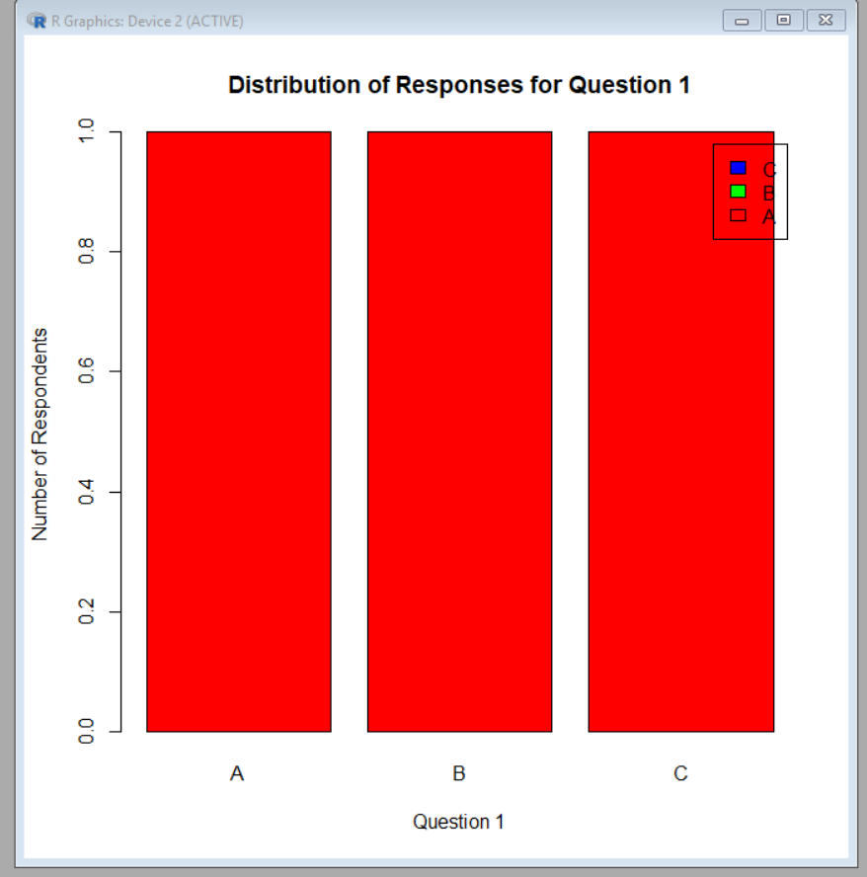

- Generate a radar chart to visualize the overall pattern of responses across all three questions.
# Install package (run once)
install.packages("fmsb")

# Load library
library(fmsb)

# Count responses for each question
A <- c(1, 1, 1) # Q1, Q2, Q3
B <- c(1, 1, 1)
C <- c(1, 0, 1)
D <- c(0, 1, 1)

# Create data frame
data <- data.frame(
Q1 = c(3, 0, A[1], B[1], C[1], D[1]),
Q2 = c(3, 0, A[2], B[2], C[2], D[2]),
Q3 = c(3, 0, A[3], B[3], C[3], D[3])
)

rownames(data) <- c("Max", "Min", "A", "B", "C", "D")

# Create radar chart
radarchart(
data,
axistype = 1,
pcol = c("red", "blue", "green", "purple"),
plwd = 2,
plty = 1,
title = "Overall Pattern of Survey Responses"
)

# Add legend
legend(
"topright",
legend = c("A", "B", "C", "D"),
col = c("red", "blue", "green", "purple"),
lty = 1,
lwd = 2
)

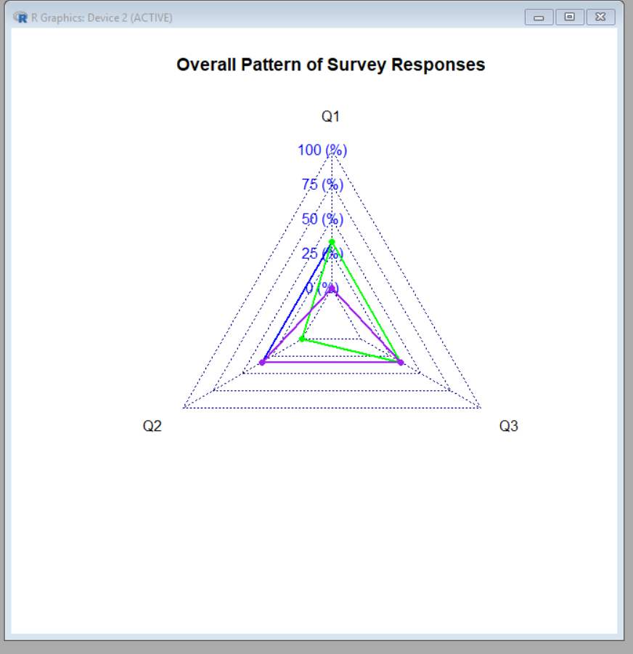

- Build a table to show the survey response data for each respondent. Label the table elements.
# Create dataset
Respondent <- c(1, 2, 3)
Question1 <- c("A", "B", "C")
Question2 <- c("B", "A", "A")
Question3 <- c("C", "D", "B")

# Create data frame
survey_data <- data.frame(
Respondent,
Question1,
Question2,
Question3
)

# Display table
print("Survey Response Data")
print(survey_data)

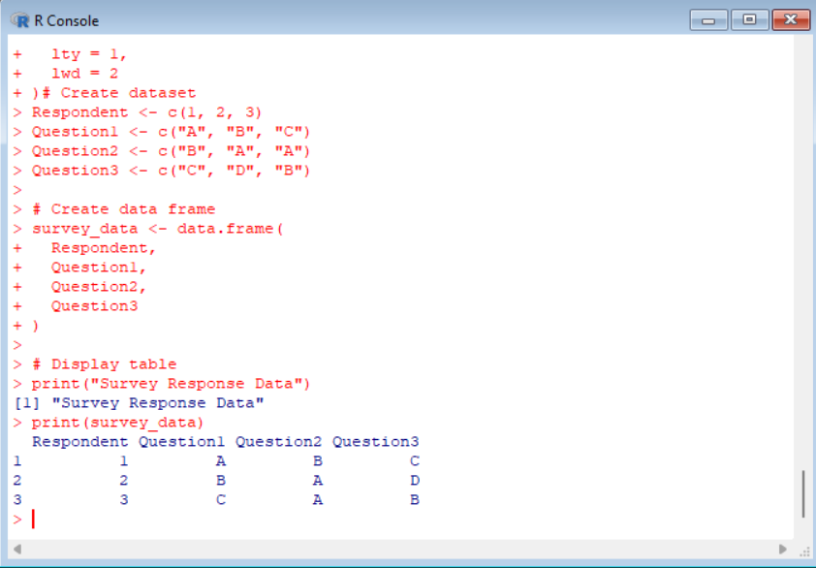

- Develop a Tableau dashboard combining the stacked bar chart, radar chart, and the table for interactive exploration of survey responses.
- 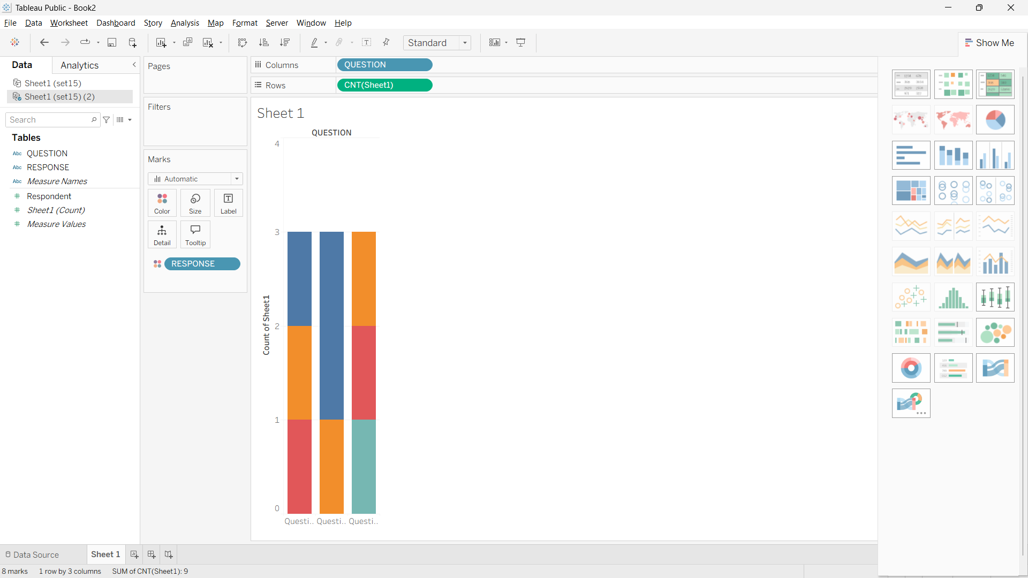

Set 15: Product Sales Analysis
Dataset: Monthly Product Sales

- Create a grouped bar chart to visualize the sales of each product for the first quarter. Label the chart elements.
# Install ggplot2 (Run only once)
install.packages("ggplot2")

# Load library
library(ggplot2)

# Create dataset
sales <- data.frame(
Product = c("Product A", "Product B", "Product C"),
January = c(2000, 1500, 1200),
February = c(2200, 1800, 1400),
March = c(2400, 1600, 1100)
)

# Convert data from wide to long format
sales_long <- data.frame(
Product = rep(sales$Product, 3),
Month = rep(c("January", "February", "March"), each = 3),
Sales = c(sales$January, sales$February, sales$March)
)

# Create grouped bar chart
ggplot(sales_long, aes(x = Product, y = Sales, fill = Month)) +
geom_bar(stat = "identity", position = "dodge") +
labs(
title = "Monthly Product Sales (First Quarter)",
x = "Product Name",
y = "Sales",
fill = "Month"
) +
theme_minimal()

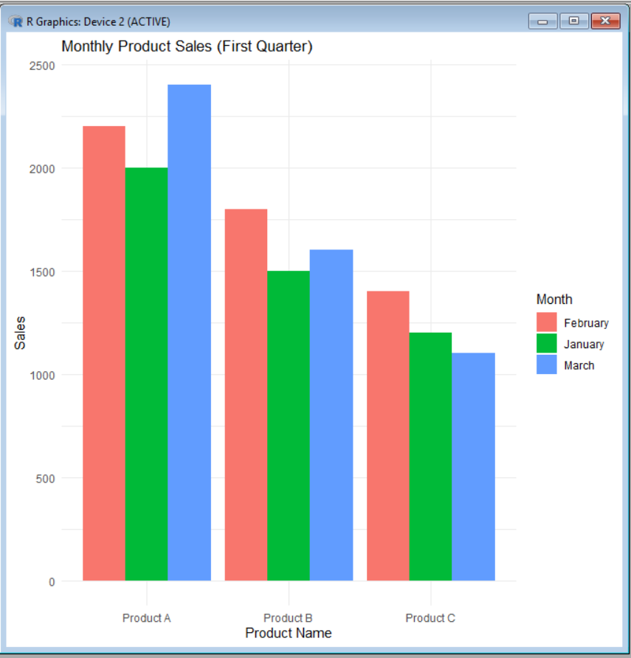

- Generate a stacked area chart to represent the overall sales trend for all products over the three months.
# Install packages (Run only once)
install.packages("ggplot2")
install.packages("reshape2")

# Load libraries
library(ggplot2)
library(reshape2)

# Create dataset
sales <- data.frame(
Month = c("January", "February", "March"),
Product_A = c(2000, 2200, 2400),
Product_B = c(1500, 1800, 1600),
Product_C = c(1200, 1400, 1100)
)

# Convert data from wide to long format
sales_long <- melt(sales, id.vars = "Month",
variable.name = "Product",
value.name = "Sales")

# Create stacked area chart
ggplot(sales_long, aes(x = Month, y = Sales, fill = Product, group = Product)) +
geom_area(alpha = 0.8) +
labs(
title = "Overall Product Sales Trend (First Quarter)",
x = "Month",
y = "Sales",
fill = "Product"
) +
theme_minimal()

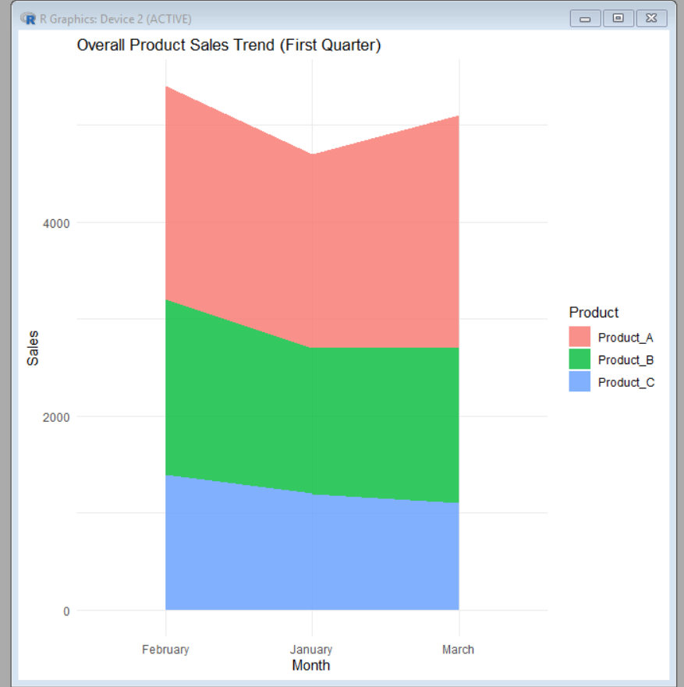

- Build a table to show the monthly sales data for each product. Label the table elements.
# Install package (Run only once)
install.packages("gridExtra")

# Load library
library(gridExtra)

# Create dataset
sales <- data.frame(
Product_ID = c(1, 2, 3),
Product_Name = c("Product A", "Product B", "Product C"),
January_Sales = c(2000, 1500, 1200),
February_Sales = c(2200, 1800, 1400),
March_Sales = c(2400, 1600, 1100)
)

# Display the table
grid.table(sales0029

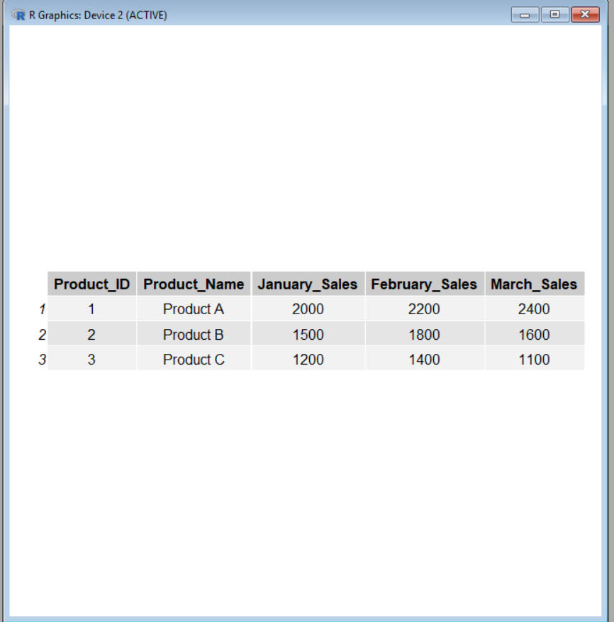

- Develop a Tableau dashboard combining the grouped bar chart, stacked area chart, and the table for interactive exploration of sales data.
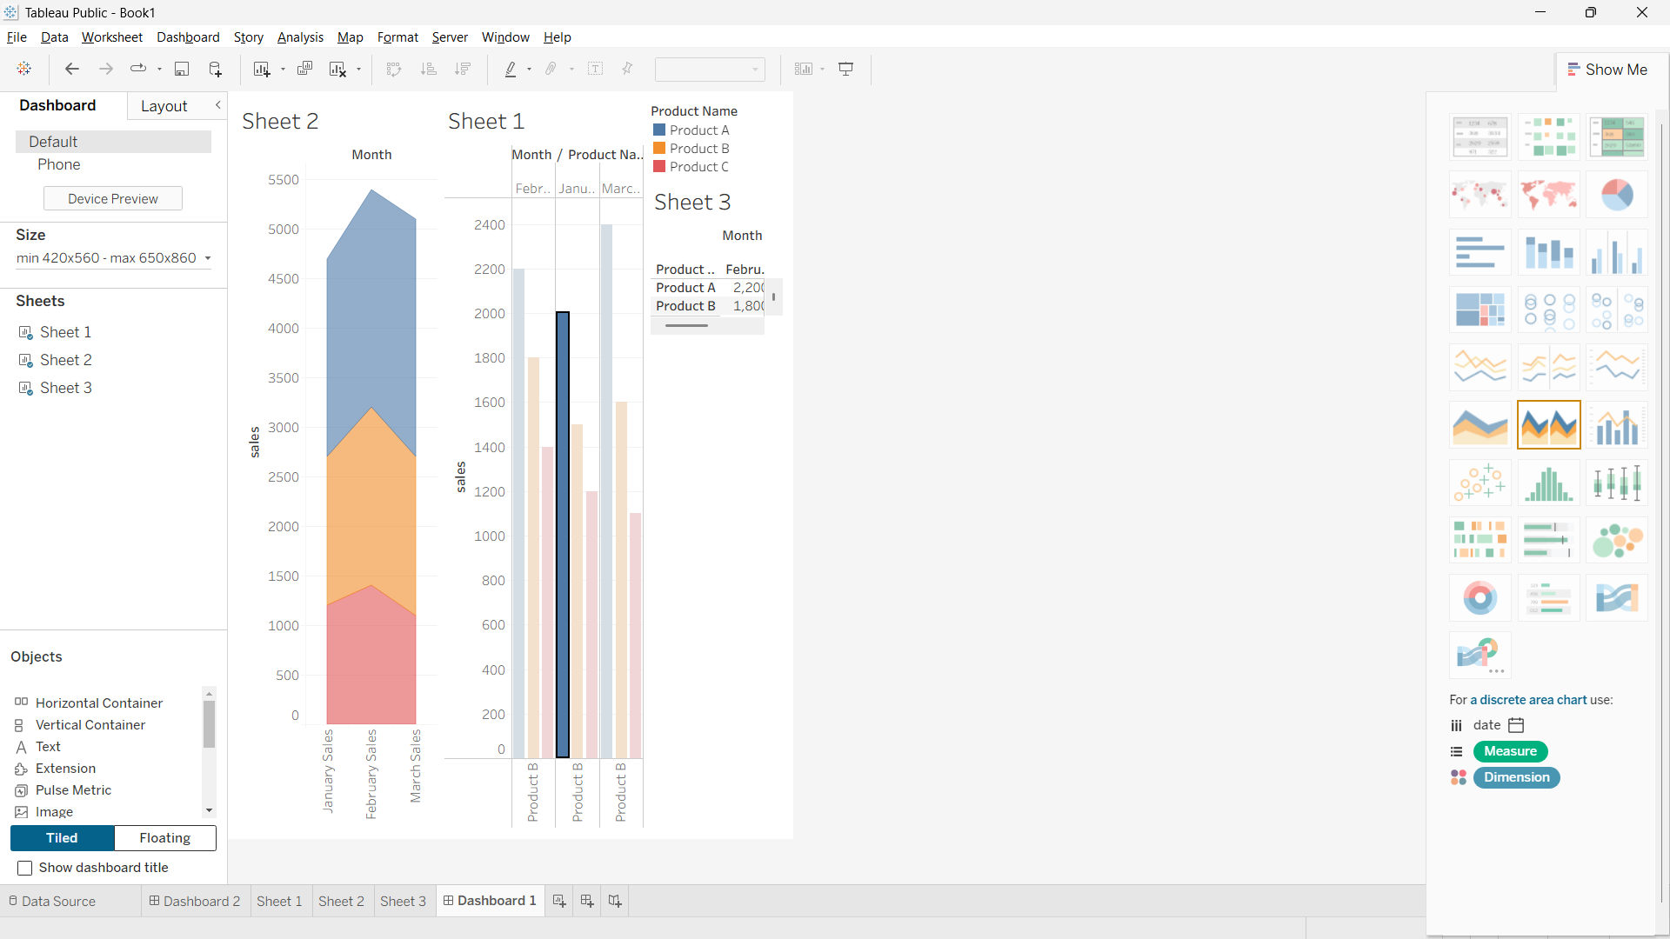

Set 16: Customer Demographics Analysis
Dataset: Customer Demographics

  - Create a bar chart to visualize the distribution of customer ages. Label the axes and title the chart.
# Customer Demographics Data
customer <- c("Customer 1", "Customer 2", "Customer 3")
age <- c(28, 35, 42)

# Create Bar Chart
barplot(age,
names.arg = customer,
col = c("pink", "lightblue", "lightgreen"),
main = "Customer Age Distribution",
xlab = "Customer ID",
ylab = "Age (Years)")

- 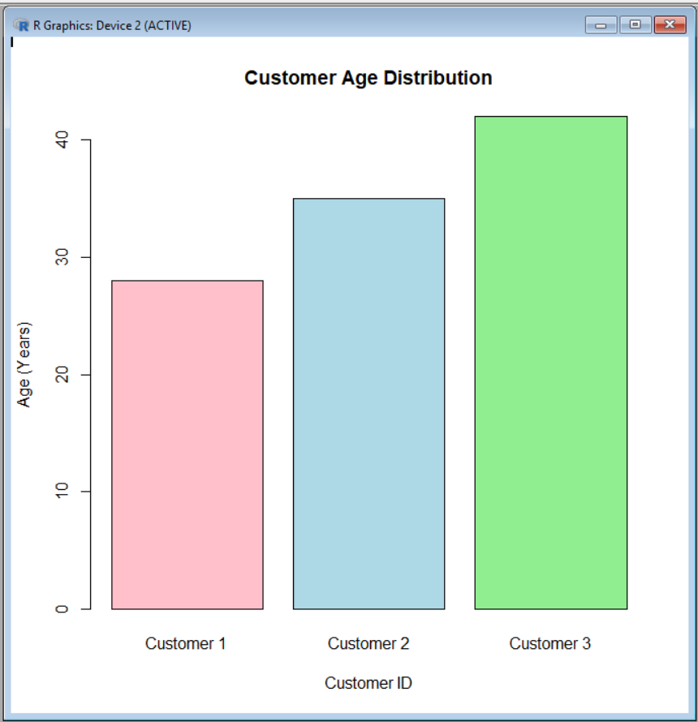

2. Generate a pie chart to represent the distribution of customers by gender.

# Customer Gender Data
gender <- c("Female", "Male")
count <- c(2, 1)

# Create Pie Chart
pie(count,
labels = gender,
col = c("pink", "lightblue"),
main = "Distribution of Customers by Gender")

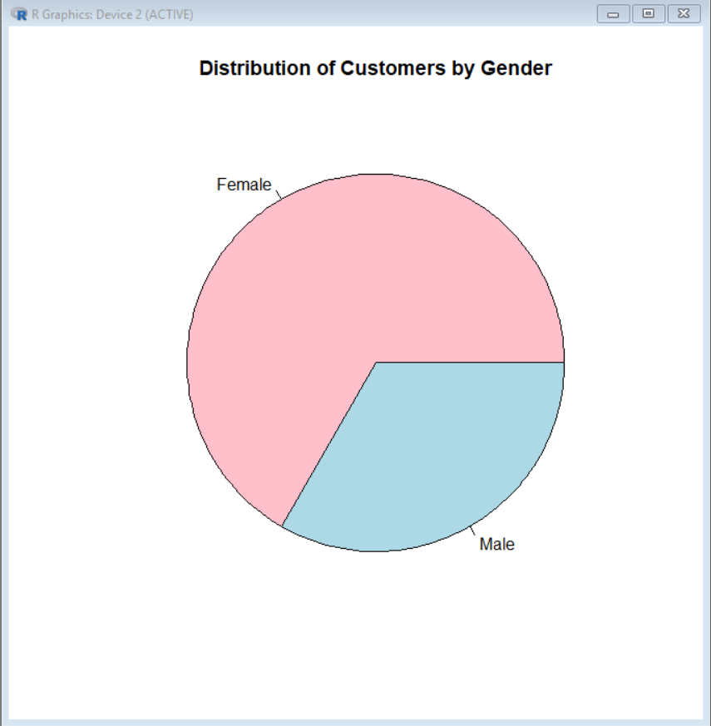

3. Build a table to show the demographic information for each customer. Label the table elements.

# Customer Demographics Data
customer_data <- data.frame(
Customer_ID = c(1, 2, 3),
Age = c(28, 35, 42),
Gender = c("Female", "Male", "Female"),
Income = c(50000, 60000, 75000)
)

# Display the Table
print(customer_data)

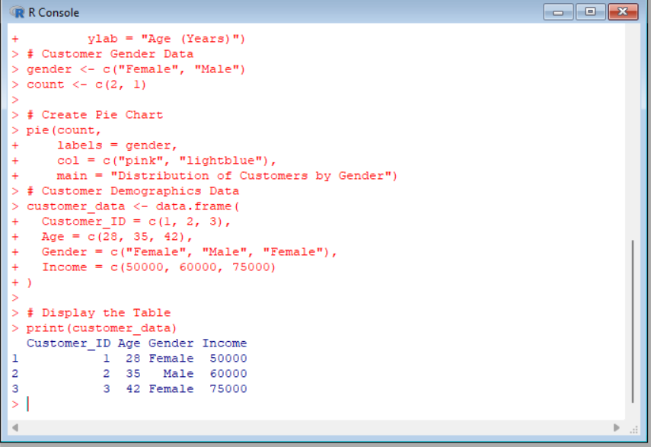

4.Develop a Tableau dashboard combining the bar chart, pie chart, and the table for interactive exploration of customer demographics.
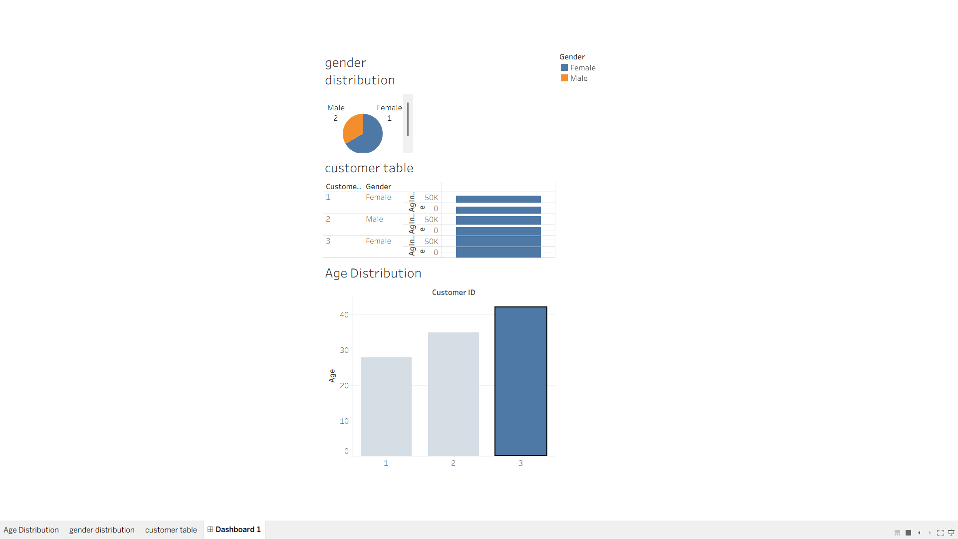

Set 17: Employee Performance Analysis
Dataset: Employee Performance

  - Create a line chart to visualize the performance trend of employees over time. Label the axes and title the chart.
# Employee Performance Data
years <- c(3, 5, 7)
performance <- c(92, 85, 78)

# Create Line Chart
plot(years, performance,
type = "o",
col = "blue",
pch = 16,
xlab = "Years of Service",
ylab = "Performance Score",
main = "Employee Performance Trend")
- 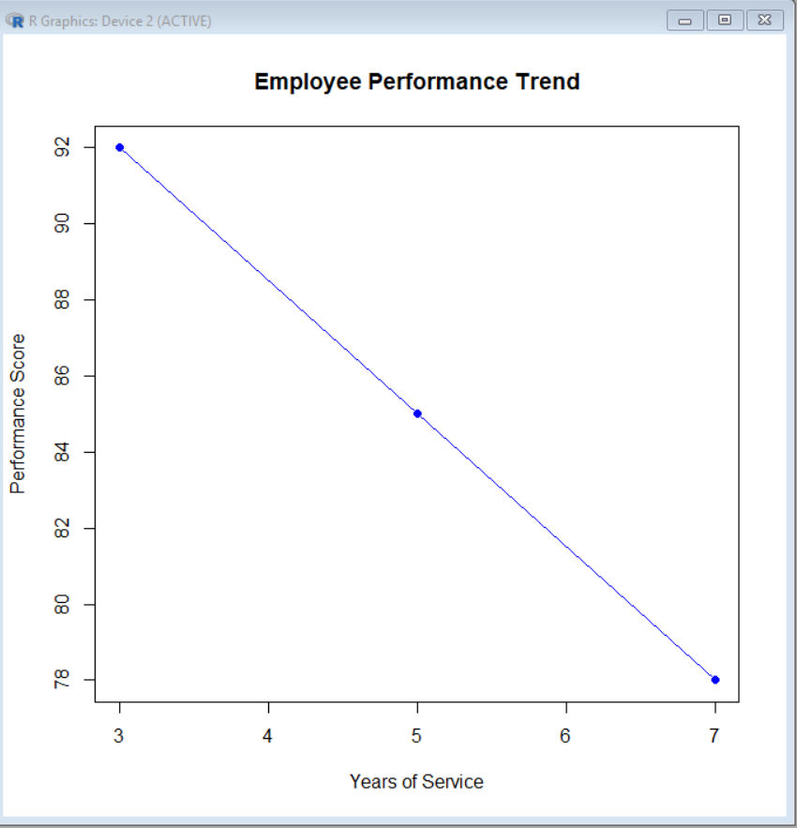
2. Generate a bar chart showing the distribution of employees across different departments. Label the chart elements.

# Employee Department Data
department <- c("Sales", "HR", "Marketing")
count <- c(1, 1, 1)

# Create Bar Chart
barplot(count,
names.arg = department,
col = c("lightblue", "lightgreen", "pink"),
main = "Distribution of Employees by Department",
xlab = "Department",
ylab = "Number of Employees")

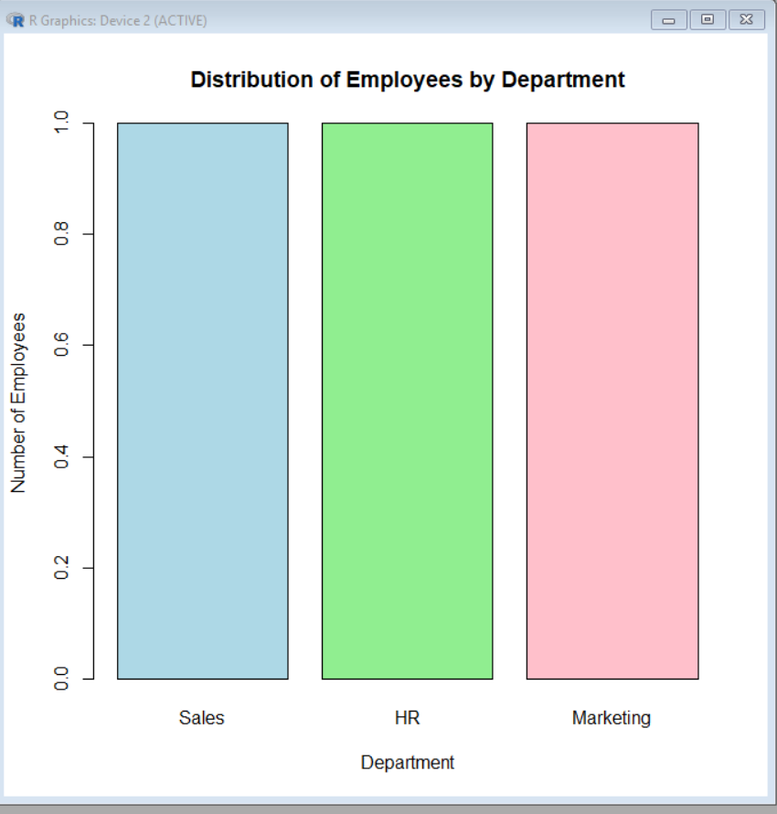

3. Build a table to display the performance data for each employee. Label the table elements.
# Employee Performance Data
employee_data <- data.frame(
Employee_ID = c(1, 2, 3),
Department = c("Sales", "HR", "Marketing"),
Years_of_Service = c(5, 3, 7),
Performance_Score = c(85, 92, 78)
)

# Display the Table
print(employee_data)

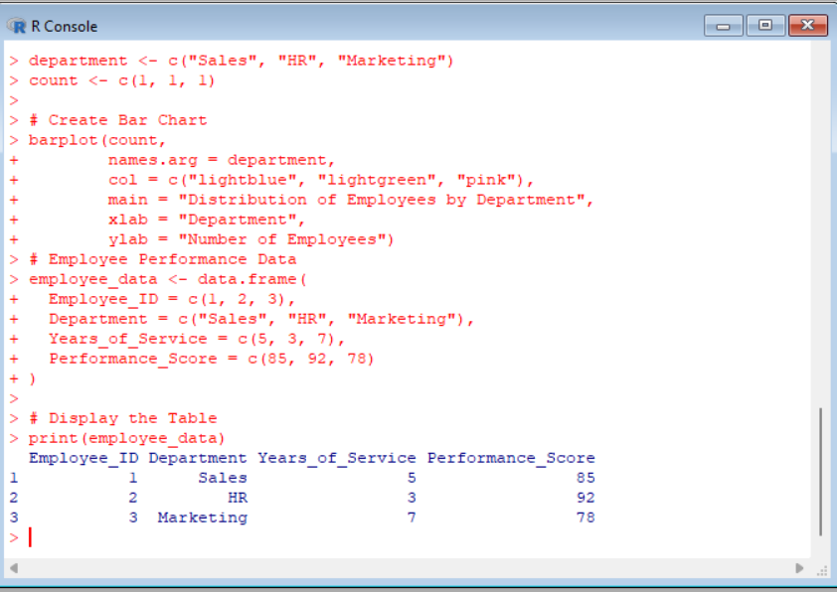

- Develop a Tableau dashboard combining the line chart, bar chart, and the table for interactive exploration of employee performance data.
